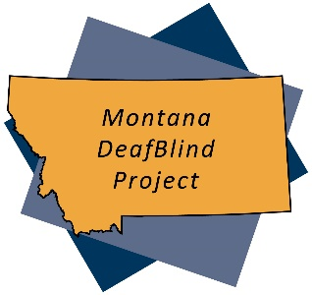

Montana DeafBlind Project

Rural Institute

University of Montana

253 Corbin Hall

Missoula, MT 59812

mtdeafblind.org

Montana DeafBlind Census Tips:

- Before starting the survey, have the student’s most recent IEP and copy of last year’s census form (if applicable) close at hand. These will help you answer some of the questions.

- After completing the census, please print a copy and retain it for your records. (This will help you in completing next year’s form.)

- Remember that the census is a “snapshot in time” based on what services looked like for this student on December 1st of the reporting year.

Thank you for your assistance in identifying Montana children with dual sensory impairments!

